**Implementing Web Application**

**Create IBM DB2 And Connect With Python**

**IBM DB2:**

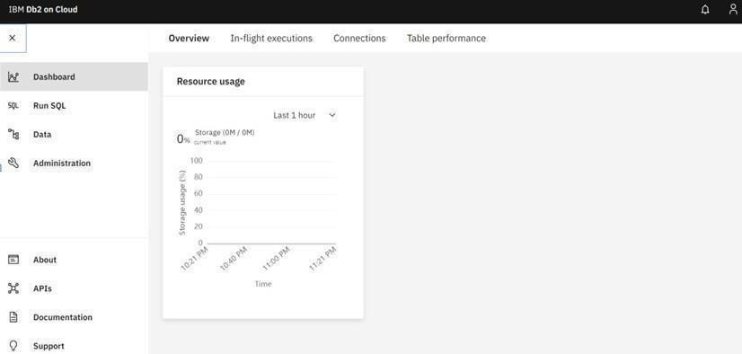

**DB2 with python:**

